https://www.thewholepkg.com/blog/3d-printed-compostable-balm-jar.htm

3D Printed Manufacturing of Custom Twist-Up Compostable Balm Jar

By Benjamin (Writer)
Maricopa, Arizona
Posted on October 22, 2014

Anita’s Balm, a company started by Anita Redd, manufactures balms for the skin, hair, lip, and eye has carried innovation a step further by designing and using a custom twist-up compostable balm jar. Founder Anita Redd started off mixing the balm at home for her son who suffers from eczema. Anita came up with a fragrance, alcohol, and dye-free, natural balm using a mix of cold pressed olive oil, and beeswax.
She started marketing the product in various roll and applicator containers when friends and family asked for the product. While she was using a roll on container, she decided to innovate when the manufacturer stopped making the product.

Improved Container
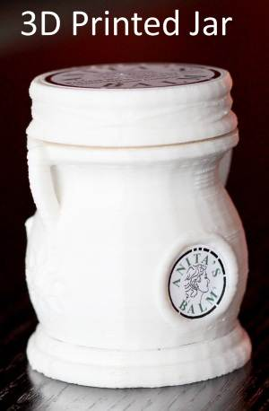
Anita used the opportunity of the withdrawal of the container line she was using to innovate and come up with a new product that was custom designed and made from compostable resins in line with her philosophy of using natural and bio degradable products.
For this Anita and Jason purchased a MakerGear M2 3D desktop printer. She experimented with design and material ideas on this with the help of her husband and his engineering skills. The MakerGear was ideal for her needs as it offers design flexibility, control, and material opportunities that Anita was looking for.

Requirements in New Container
Anita wanted a new container that would facilitate roll on application of the balm as this is the best way to use the formulation. She was also looking for a natural and eco-friendly container to reflect both her personal philosophy and that of her customers. She also wanted the tube to look like a jar and to be able to modify the design as per her requirements and manufacture the container in-house instead of depending on purchased containers that could lead to delays in shipping her orders. Another major consideration was keeping overall costs low.

Advantages of 3D Printed Containers
The 3D printed containers designed by Anita and Jason and manufactured in house by Anita’s Balm meet all of these criteria. The cost of production is low and the business saves time and money by avoiding shipping costs and delays. Moreover, the use of PLA pellets ensures that the container is compostable by multiple standards such as ASTM, ISO, and EN. This means that consumers can be assured that the empty jars will not end up in landfills. Moreover, Anita’s Balm can inexpensively tweak the design and produce new types of containers without investing in expensive injection molds.
The entire process of producing the five components of the amphora type twist up balm jar used by Anita’s Balm and assembling them, filling them, and shipping the jars takes only a few hours after an order is placed, ensuring that customers can be satisfied.
Anita also loves the design elements and texture made possible by the PLA fiber and 3D printing technology. The company can also change the color of the container if they want to be without having to include heavy investments or making major changes in the production or assembly line.

